**OCAF Initial Application Board President Signature and Submission**



**Knowledge Base Article**

**Table of Contents**

**Overview** 3

**Navigating the OCAF Login** 4

**Acknowledge, Sign and Submit Application** 6

**Overview**

This User Guide will review how to sign and submit an Initial Certification Application as a Board President within the Ohio Certification for Agencies and Families (OCAF) System.

Once an Agency Administrator has added a Board President to the application, an email will be sent to the Board President prompting them to create an account in OCAF so they can provide their signature and attestation acknowledgement. See below:

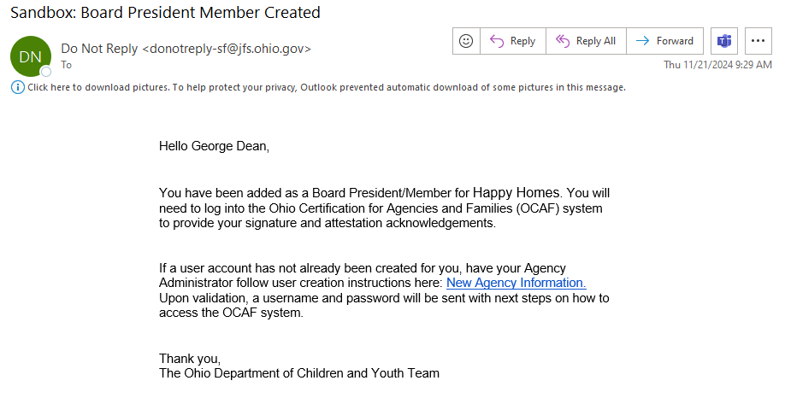

Follow the instructions listed in the email to gain access to the Ohio Certification of Agencies and Families (OCAF) system. Once access is granted, continue with this user guide for further instruction.

**Navigating the OCAF Login**

Once access is granted to the OCAF system, the user will receive an email with a **Link** and **Username** to verify their account. Follow the instructions in the email. See below for an example.

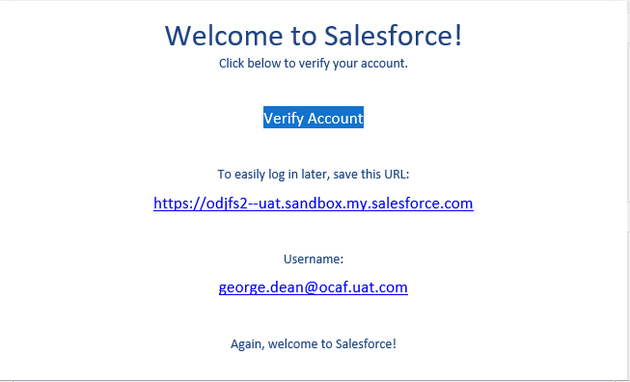

1. Save the **Username** provided.
2. Click the **Verify Account** button.

The user will be navigated to a browser window and prompted to change the **Password** for their newly created OCAF account. See below:

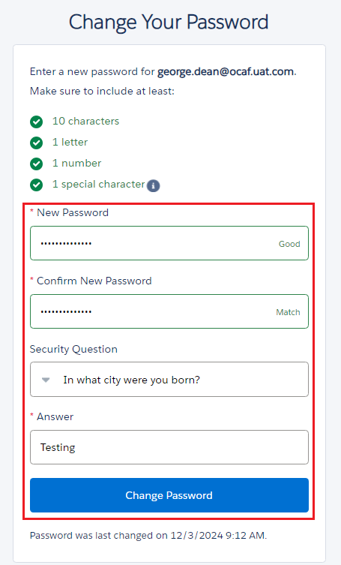

1. Create **New Password**.
2. **Confirm New Password**.
3. Make a Selection from the **Security Question**.
4. Provide an **Answer** for the Security Question.
5. Click the **Change Password** button.

A browser window will open to the **OCAF Home** screen. Here the user can see the **Initial Certification Application**.

**Acknowledge, Sign and Submit Application**

1. Click the **Resume Application** button.

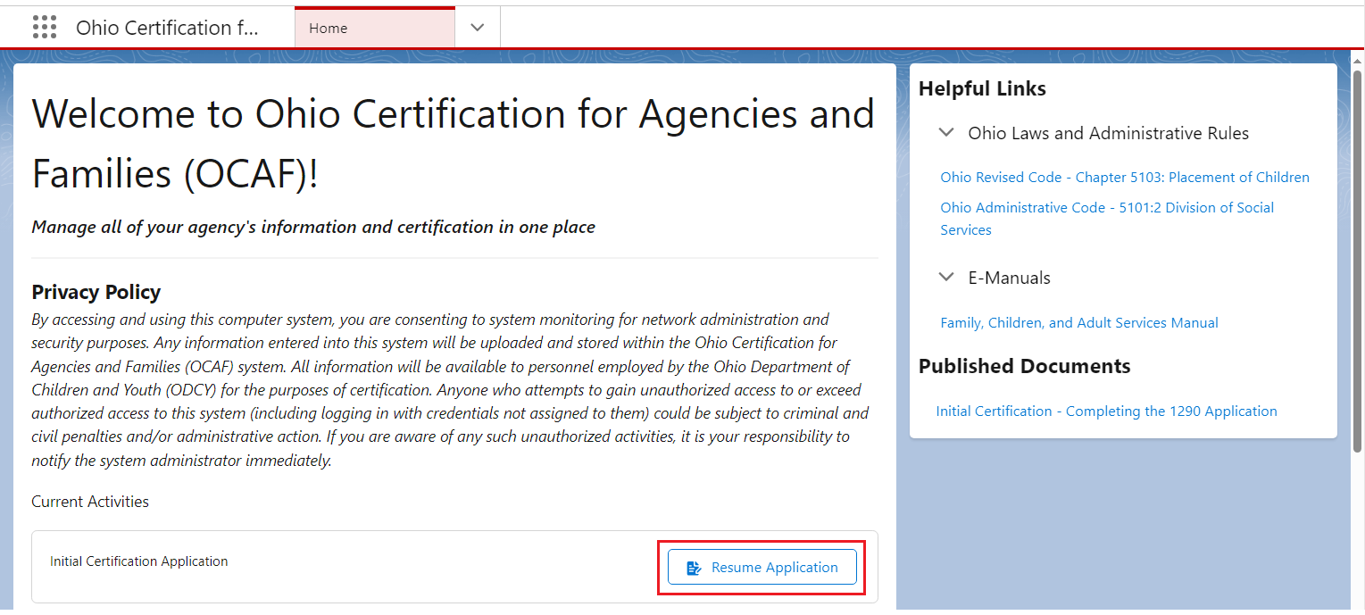

For the purpose of this User Guide, the Agency Administrator has already completed all the information in the application. The Board President may click through the application and verify all the information is correct before acknowledging and signing the application. If you need more information on completing the application, please refer to this User Guide: (Insert when completed)

1. Navigate to the **Licensing Agreement** screen.
2. From the **Licensing Agreement** screen, checkmark the box for **As the Board President I do acknowledge and assure the above affirmations and assurances**. (Required)
3. Click **Save and Continue**.

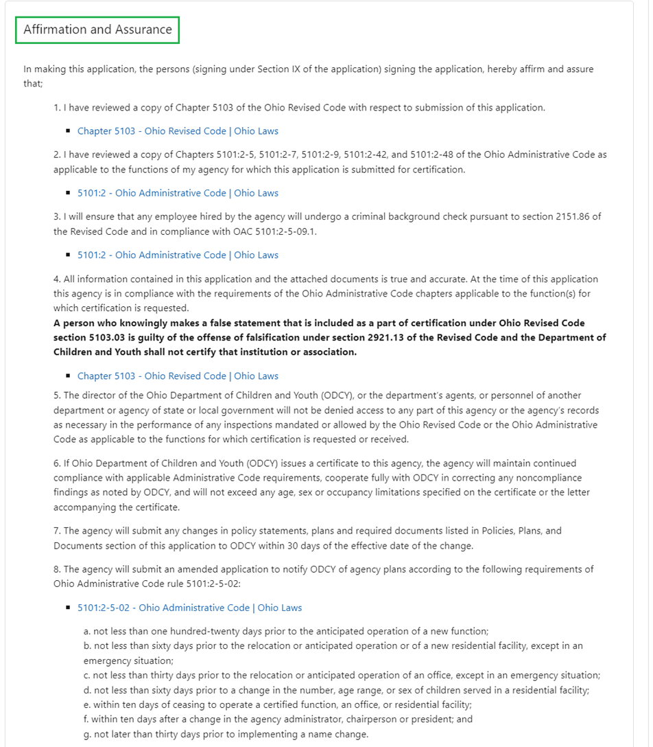

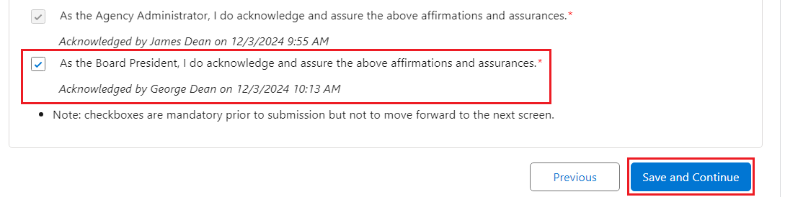

The **Signatures and Submission** screen displays.

1. Board President, **Sign the Application**.
2. Click **Save Signature**.

**Note:** The **Save Signature** button disappears when clicked. It will then display the Name, Date and Time the signature was saved as shown below.

1. Click the **Submit** button.

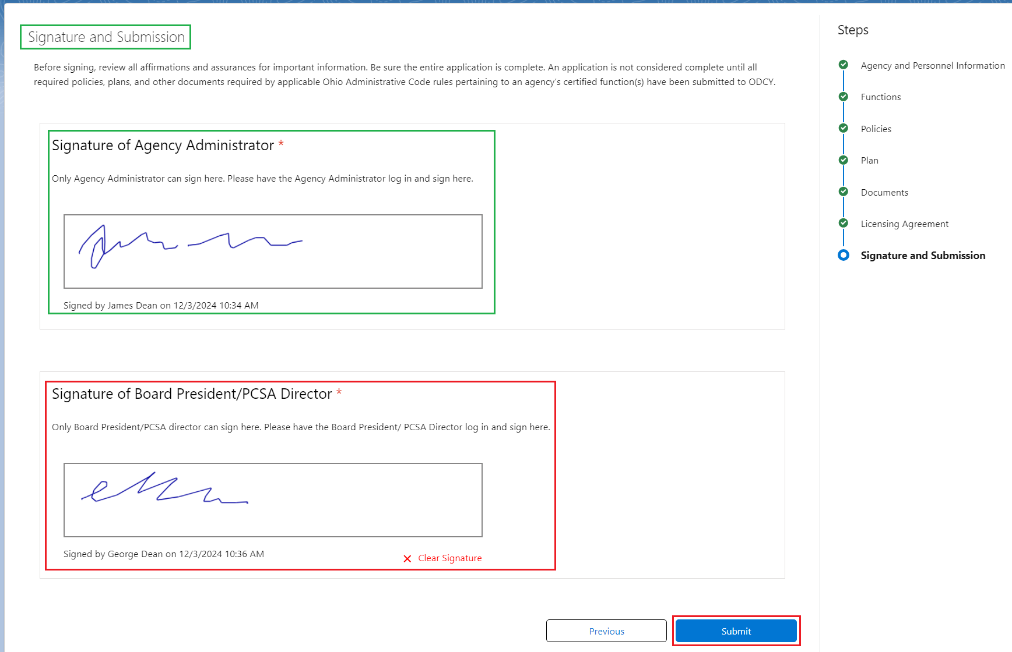

A message displays verifying the application was submitted.



From the **OCAF Home** tab, the Initial Certification Application shows as **Submitted**.

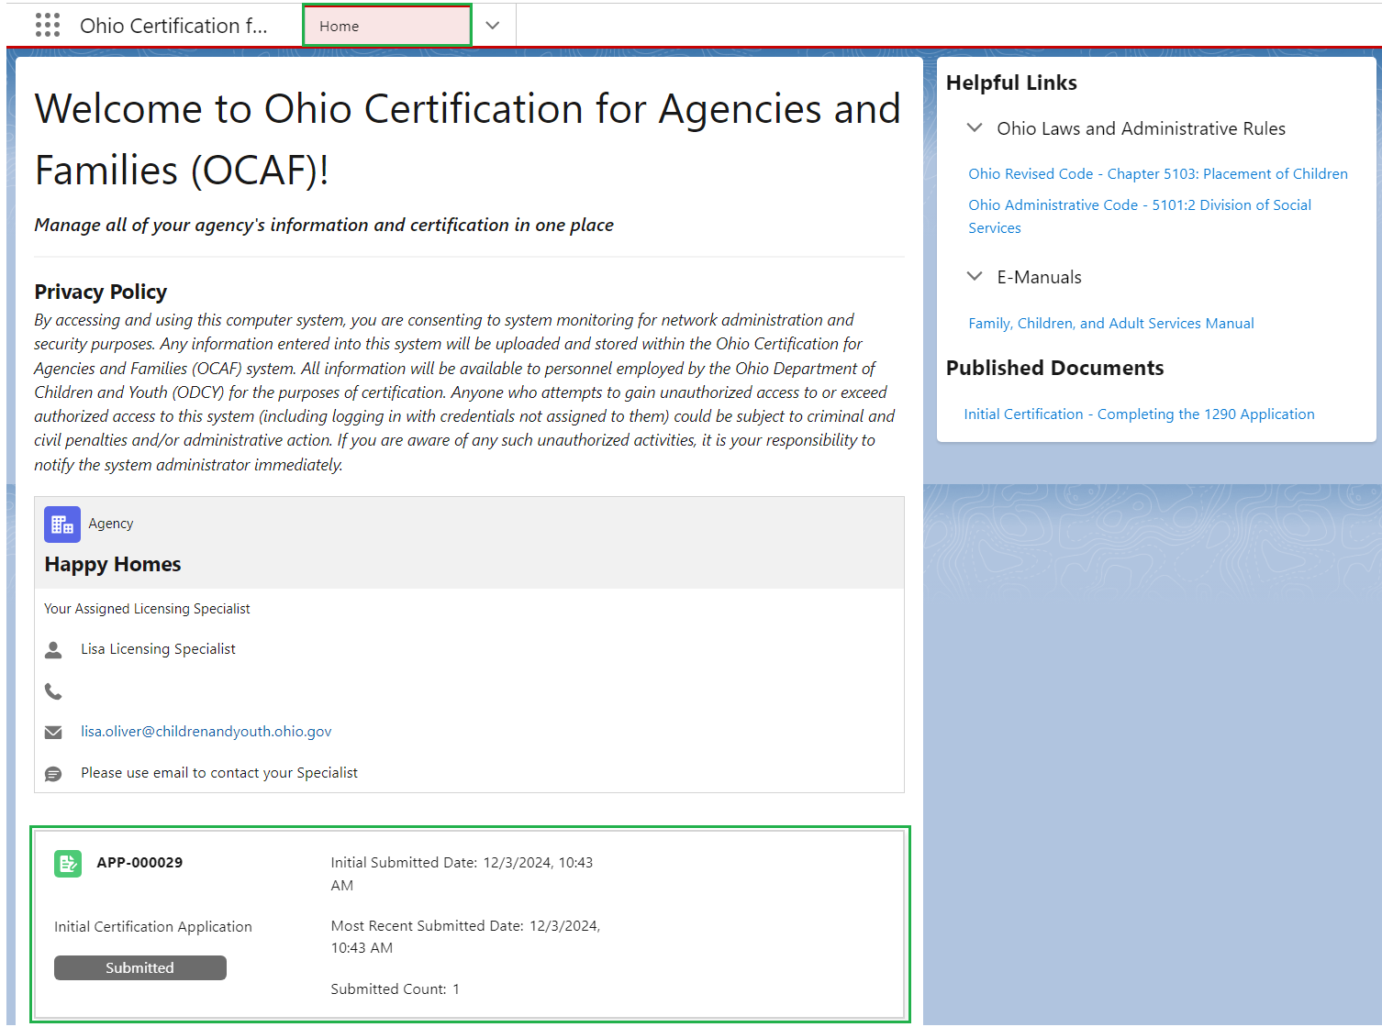

If you have additional questions pertaining to this Deployment Communication, please contact the [Customer Care Center](https://gcc02.safelinks.protection.outlook.com/?url=https%3A%2F%2Fodjfs2.my.site.com%2FCustomerCareCenter&data=05%7C02%7CLisa.Oliver2%40jfs.ohio.gov%7C989cf850d37046f616fb08dc62ce48c2%7C50f8fcc494d84f0784eb36ed57c7c8a2%7C0%7C0%7C638493885340155072%7CUnknown%7CTWFpbGZsb3d8eyJWIjoiMC4wLjAwMDAiLCJQIjoiV2luMzIiLCJBTiI6Ik1haWwiLCJXVCI6Mn0%3D%7C0%7C%7C%7C&sdata=m7Jj%2FJgZoByjWSmS1yVsBvkU74K5cBrLFP0FC1bFFvo%3D&reserved=0).